**Notes of Laravel**

1. **Install Laravel Project**

* Download and Install Composer
* Install Larvael

compose r create-project --prefer-dist laravel/laravel [project_name]

* Start the project

php artisan serve

1. Problem:

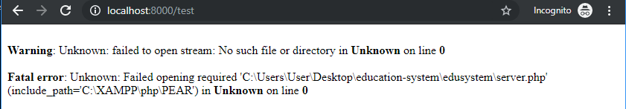

Cause: server.php file is deleted by AntiVirus software.

Solution: Close anti-virus software and copy and past a server.php file.

1. Install Bootstrap

npm install

in you <head>, add script and style

<script src="{{ asset('js/app.js') }}" defer></script>

<link href="{{ asset('css/app.css') }}" rel="stylesheet">

1. Asset()

This method is used to include CSS/JavaScript/Images files, you can use in this cases:

<link href="{{ asset('css/min.css') }}" rel="stylesheet">

<script src="{{ asset('use.typekit.net/zjb5wvv.js') }}"></script>

<img alt="logo" src="{{ asset('images/logo.png') }}">

The files must located in the public folders.